Spalding Rules
1-29
From The Writing Road to Reading

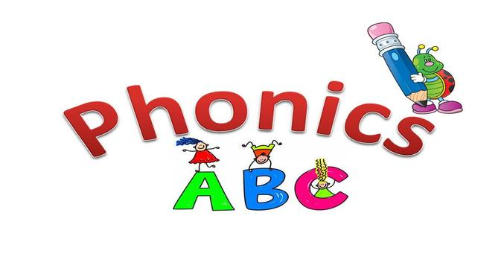

Spalding Rules 1-29

Rule 1: The letter q is always followed by u.
Rule 2: The letter c before e, i, or y says s (cent, city, cycle), but followed by any other letter says k (cat, cot, cut).
Rule 3: The letter g before e, i, or y MAY say j (page, giant, gym), but followed by any other letter it says g (gate, go, gust). The letters e and i following g do not always make the g say j (get, girl, give).
Rule 4: Read and underline a, e, o, and u at the end of a syllable when they say /a/, /e/, /o/, and /u/.
Rule 5: Read and underline i and y at the end of a syllable only when they say /i/.
Rule 6: Write y, not i, at the end of an English word.
Rule 9: 1-1-1 rule; When you have a word with one syllable, with one vowel followed by one consonant (hop), double the consonant (hopping) before adding a suffix that begins with a vowel.
Rule 10: 2-11 Rule: When you have a word with two syllables in which the second syllable is accented and ends in one vowel followed by one consonant (be gin), double the consonant (beginning) before adding the suffix that begins with a vowel.
Rule 11: When a word ends in final silent e, write the word without the e before adding a suffix that begins with a vowel.
Rule 12: Write ie except after c; however if we say /a/, use ei, unless it’s an exception. See Rule Page 5 for the list of exceptions.
Rule 13: Write sh to say /sh/ at the beginning or end of words, and at the end of syllables.
Rule 14: Write ti, si, and ci to say /sh/ in syllables after the first one.
Rule 15: Write si to say /sh/ if the preceding syllable or base word ends in s.
Rule 16: The phonogram si may also say /zh/.
Rule 17: We often double the l, f, and s following a single vowel at the end of a one syllable word (such as will, off, miss). This sometimes applies to two syllable words like recess.
Rule 18: Write ay to say /a/ at the end of a word.
Rule 19: Vowels i and o may say /i/ and /o/ if followed by two consonants (such as in the words find, old).
Rule 20: The letter s never follows the letter x.
Rule 21: All, written alone, has two l’s, but when written with another syllable, only one l is written (al so, al most).
Rule 22: Till and full, written alone, have two l’s, but when written with another syllable, only one l is written.
Rule 23: Write dge to say /j/ after a single vowel that says its first sound (a, e, i, o, u).
Rule 24: When adding an ending to a word that ends with a consonant and y, use i instead of y unless the ending is ing. (baby-babies, try-tried)
Rule 25: Write ck to say /k/ after a single vowel saying its first sound (a, e, i, o, u).
Rule 26: Words that are proper nouns-the names or titles of people, places, books, days, or months- are capitalized.
Rule 27: Write z to say /z/ at the beginning of words.
Rule 28: Past tense ending:
The phonogram ed has three sounds. If the base word ends in the sound d or t, adding ed makes another syllable that says ed (hand ed, land ed, paint ed, plant ed). If the base word ends in a voiced consonant sound, the ed ending says d (lived, killed). If the base word ends in an unvoiced consonant sound, the ending says t (jumped).
Rule 29: Words are usually divided between double consonants.
Read double consonants in both syllables for spelling (lit tle).
Read only the consonant in the accented syllable for reading (lit le).
